Answer 2
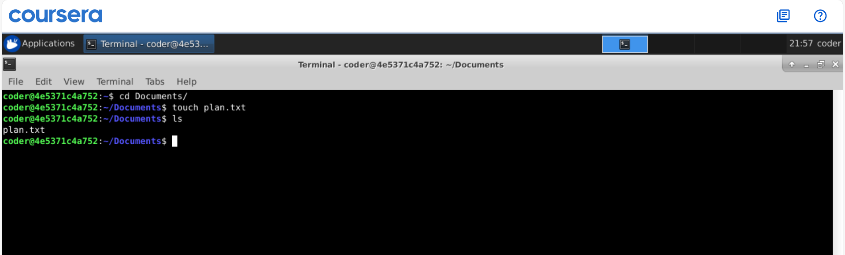
Explanation: As asked, I went to Documents directory using cd command and created a plan.txt text file using touch command. Now instead of using many commands we can do all this in 1 line touch ~/Documents/plan.txt

